|  |  |  |  |
| --- | --- | --- | --- |
|  | 1/22/2019 |  | |
| |  |  | | --- | --- | |  |  | |  |  | |  |  | |  |  | | |  | |
| Functional Design | | | |
|  |  | | |  |  |  | | --- | --- | --- | |  |  |  | |  |  |  | |  |  |  | |  |  |  | |  |  |  | |  |  |  | |
|  |  | | ITV2H-01 |

Client: Kampot Cement

Projectgroup: ITV2H01

Dennis Harms 380176

Joppe Klaver 373471

Kyle Gravenhorst 376772

Maiwand Rasulzadeh 340238

Karel Koster 361252

# Table of contents

## Introduction

## Requirements

## Web application

## Login system

## Graphs

## Admin privileges

## Weather stations

# Introduction

Kampot Cement is a company that makes Cement. Kampot Cement is located in Cambodia and needs actual weather data to decide if the conditions for making and transporting cement are right. Our company got the opportunity to make an application for Kampot Cement where they can view the weather in and around Cambodia in real time. In this functional design we will show the first draft of our application and how to use it, the technical aspect will be discussed in the technical design.

# Requirements

After a first meeting with Kampot Cement they made clear what the application should be able to do. All requirements can be divided in 4 groups:

**Must have**

(the application must have these features or else it can not be used)

**Should have**

(The application should have these features, but they are not necessary)

**Could have**

(The application will have these features if all the must and should haves are already implemented)

**Won’t have**

(The application will not have these features, but the features could be implemented in a future project)

|  |  |  |  |
| --- | --- | --- | --- |
| Must have | Should have | Could have | Won’t have |
| Data encryption |  |  |  |
| Secured login |  |  |  |
| Admin account |  |  |  |
| 98% accurate data | 100% accurate data | View raw data. |  |
| Graphs displaying the data.  Easy to use and understand | Linegraphs and bargraphs for rainfall, humidity and temperature. |  |  |
| Web application refreshes every 10 seconds | Real time updates |  |  |
| Option to download data | Download data as csv file(excel). Have an option to select more or less data. |  |  |

# Web application

The web application will be easy to understand for the employees of Kampot Cement. To use the application they won’t need to install anything new on their computer, once the application is online Kampot Cement can start using it immediately.

# Login system

When going to the site, users and admins have to log in before being able to see the data. People from outside will not be able to log in to the site and see the data. Employees need to log in using their email and a password. The password needs to contain at least one uppercase letter, one lowercase letter and one number.

Only admins can create and delete accounts. So when a new employee needs access to the system an admin needs to create an account first. When an employee stops working for Kampot Cement admins can delete their account so they will not be able to log in to the system anymore. All passwords will be encrypted for security reasons.

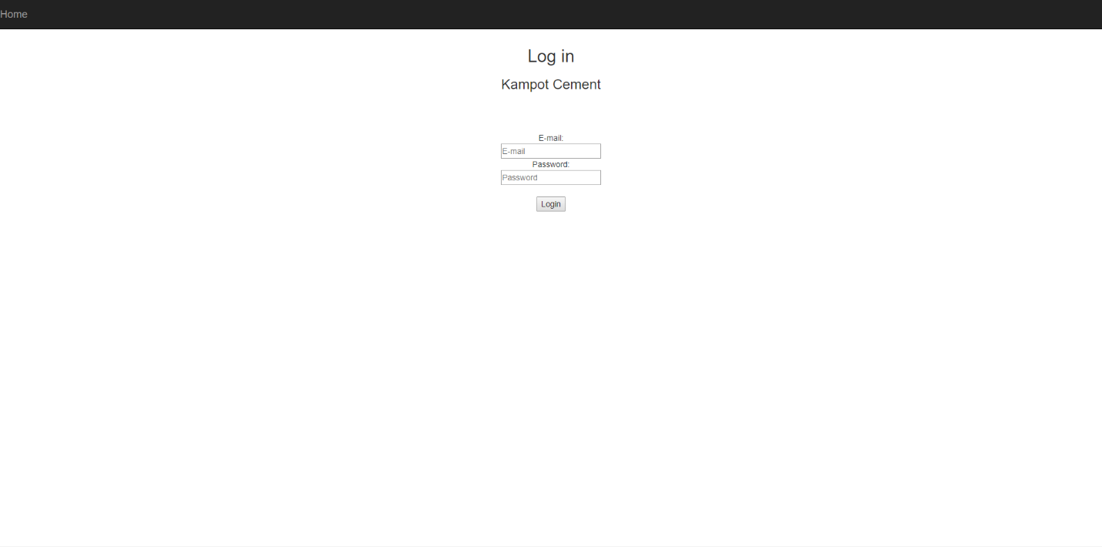

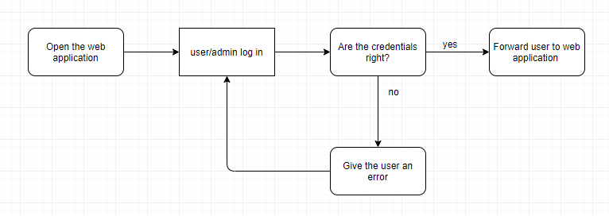

# Graphs

Once logged in on the website users and admins are able to see the data in graphs. The page is called graphs and will display multiple graphs containing relevant weather data. These graphs can be used by Kampot Cement to make decisions concerning the production or transport of their product.

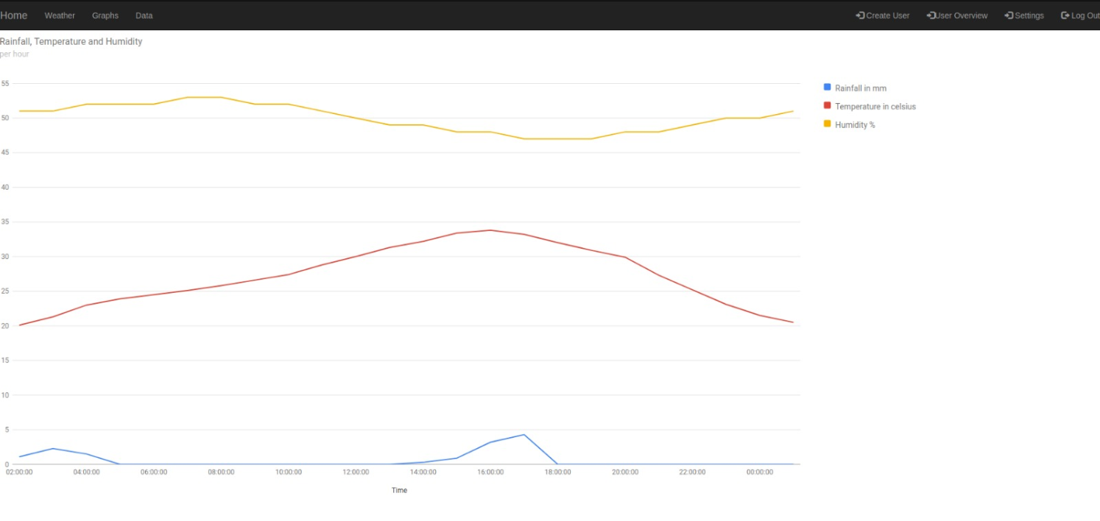

# Admin privileges

There are 2 types of employees on the web application, normal users and admins. Admins can do more than normal users. The admin privileges are: creating users, deleting users, edit user info. The buttons in the menu bar on the right are only visible for admins and not for normal users.

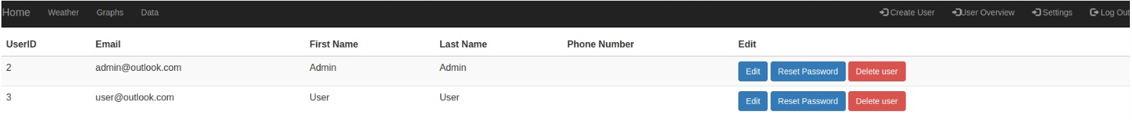

# Weather stations

The weather data will be collected from weather stations in and around Cambodia. We will use all weather stations in Cambodia, Laos, Thailand, Vietnam and the South Chinese Sea. All the data will be visible in the web application for Kampot Cement.

The exact area of all weather stations is:

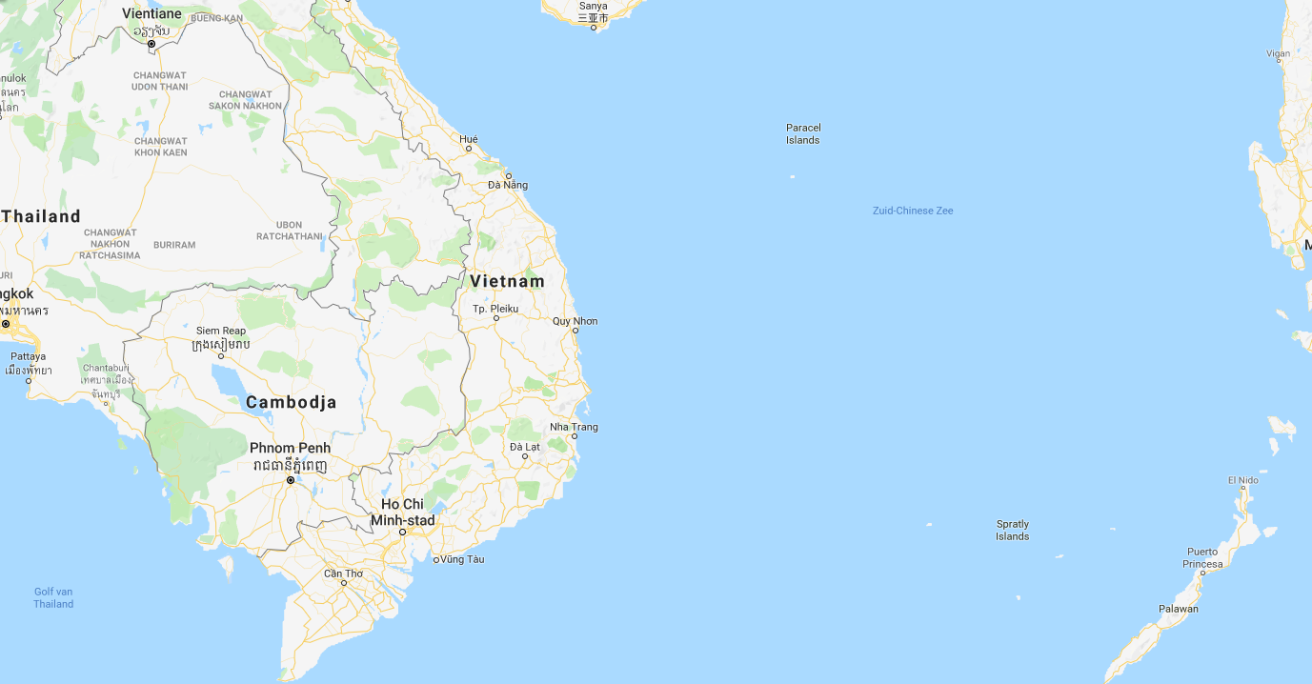

latitude between 10.755452 and 18.673342

longitude between 100.5017651 and 120.9842195